**Source : https://www.un.org/events/smallarms2006/pdf/arms060627tanzan-eng.pdf**  
  
In 2001, the UN Programme of Action on Small Arms and Light Weapons set a number of implementation benchmarks at the national, regional and international levels for us all . In implanting the Programme, Tanzania has achieved modest progress .

It is in this regard that we also emphasize the linkage between the illegal exploitation of natural resources, illicit trade in such resources and the proliferation and trafficking of small arms and light weapons as one of the factors Fueling and exacerbating the same .

Amidst these challenges we have notable achievements in arms reduction activitïes, record keeping and public awareness . From 2001 - 2005 for instance, Tanzania destroyed more than 5500 firearms and ammunitions .

We however believe that it would be more productive if the issues relating with Small Arms and Light Weapons would be included in the development agenda and national development strategies, so that development partners can devote more resources in the implementation of UN Programme of Action at all levels .

ILLICIT TRAFFICKING OF WEAPONS : -  
  
**SOURCE :** https://economictimes.indiatimes.com/news/defence/foreign-supplied-weapons-to-ukraine-raise-fears-of-smuggling-to-far-away-conflicts-terror-groups/articleshow/93402138.cms?from=mdr

**In the wake of rising arms smuggling in Ukraine amid its ongoing conflict with Russia,**

**It will feed into violence in the criminal networks in European Union.**

**Notably, amid urgent pleas from Ukrainian President Volodymyr Zelensky to boost weapons and ammunition supplies to help counter Russian advances in the country’s east and south.**

**Washington’s heavy outpour of missiles, rockets, and artilleries to war-torn Ukraine recently has raised fears of the powerful weapons entering Ukraine’s illicit arms market and that some of them could also re-emerge in faraway conflicts for decades to come.**

**The stocks of weapons the US already committed to Ukraine, including 1,400 Stinger antiaircraft systems, 5,500 antitank missiles, 700 Switchblade drones, 90 long-range Howitzers artillery systems, 7,000 small arms, 50,000,000 rounds of ammunition, and numerous other mines, explosives and laser-guided rocket systems.**

## Ukraine has a history of illegal arms trade with the most prominent case being that of the MV Faina, a Ukrainian cargo ship that was caught trafficking tanks, artillery and AKM assault rifles to Sudan in 2009. The incident came to light when the ship was captured by Somali pirates.( said by China, Bosnia and Herzegovina and Bangladesh)

**To combat this menace EU is creating a hub in Moldova to fight arms smuggling Ukraine. EU home announced the EU Support Hub for Internal Security and Border Management at a meeting of EU interior ministers. The meeting in Prague focused on the threat of weapons — many of them supplied by the West — being smuggled out of Ukraine to equip crime gangs in Europe.  
The overflow of international military aid to Ukraine is turning into a ticking time bomb. Combined with a complete lack of control by Western and Ukrainian authorities, it has provided a seemingly endless supply of advanced weaponry for black markets around the world.**

**WMDS :**

**SOURCE : https://globalchallenges.org/global-risks/weapons-of-mass-destruction/#:~:text=Its%20immediate%20effect%20would%20be,dramatic%20ecological%20consequences%2C%20severe%20agricultural**

On August 6, 1945, a nuclear bomb exploded in Hiroshima, killing some 70,000 people within the day & bringing the total number of deaths to some 150,000.Since then, the world has lived in the shadow of a war unlike any other in history. Although the tension between nuclear states has diminished since the end of the Cold War and disarmament efforts have reduced arsenals, the prospect of a nuclear war remains present, and might be closer today than it was a decade ago. Its immediate effect would be the catastrophic destruction of lives and cities, and debilitation, illness and deaths from radiation, but another concern is the risk that the dust released from nuclear explosions could plunge the planet into a mini ice-age, with dramatic ecological consequences, severe agricultural collapse, and a large proportion of the world population dying in a famine.

**From agreements following World War I to ban mustard gas to the establishment of the International Atomic Energy Agency to the nearly universal acceptance of the Nuclear Nonproliferation Treaty to the inauguration of the Chemical Weapons Convention in 1997, the international community has made great strides in limiting states’ ability to pursue, and interest in pursuing, WMD. Libya’s recent decision to dismantle and allow international inspections of its own WMD program serves as evidence of the effectiveness of today’s nonproliferation regime.**

In March 1996, Tanzania, [Uganda](https://en.wikipedia.org/wiki/Uganda" \o "Uganda), and [Kenya](https://en.wikipedia.org/wiki/Kenya" \o "Kenya) revived discussion of economic and regional cooperation. These talks culminated with the signing of an East African Cooperat…………………………………………..ion Treaty in September 1999, which should in time lead to [economic integration](https://en.wikipedia.org/wiki/Economic_integration" \o "Economic integration) through the development of the [East African Community](https://en.wikipedia.org/wiki/East_African_Community" \o "East African Community). Tanzania is the only country in [East Africa](https://en.wikipedia.org/wiki/East_Africa" \o "East Africa) which also is a member of the [Southern African Development Community](https://en.wikipedia.org/wiki/Southern_African_Development_Community" \o "Southern African Development Community) (SADC).

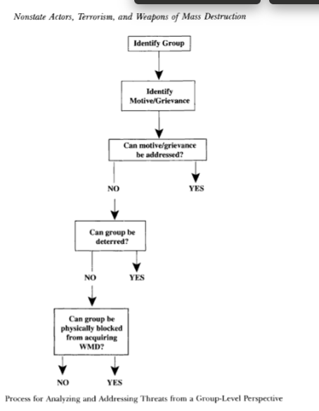Historically, Tanzania has played an active role in hosting refugees from neighbouring countries including Mozambique, DR Congo, Burundi, and Rwanda. This normally has been done in partnership with the United Nations High Commissioner for Refugees.